**LAB 4 - HLOOKUP EXERCISE**

1. Use HLOOKUP to find the sales for Product A in March

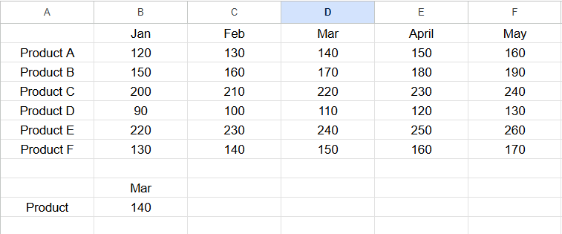

2. Use HLOOKUP to find the sales for Product D in May

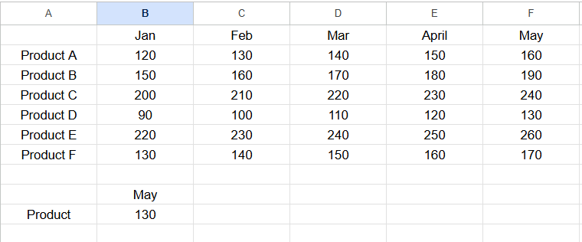

3. Use HLOOKUP to find the sales for Product C in February.

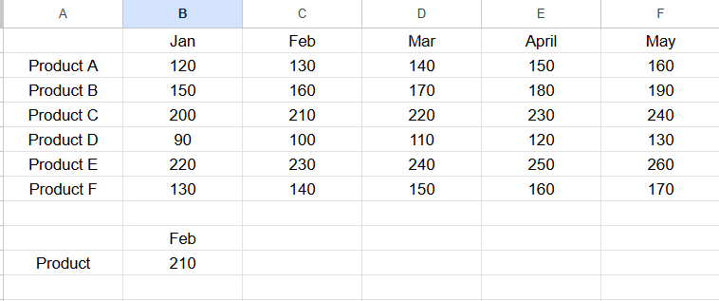

4. Use HLOOKUP to find the sales for each month for a product, then calculate the total sales for that product.

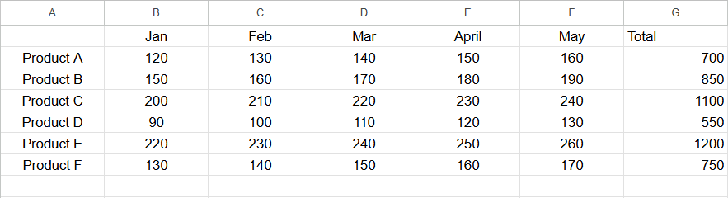

5. Use HLOOKUP to find the maximum sales value for Product B across all months.

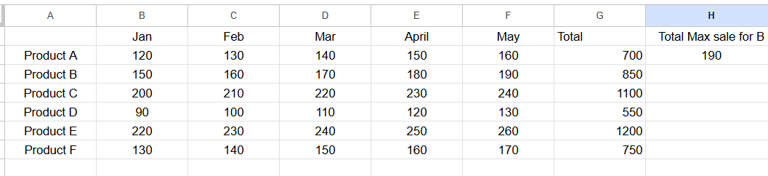

6. Use HLOOKUP to find the minimum sales value for Product F across all months.

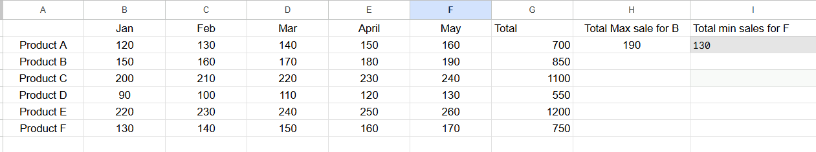

7. Use HLOOKUP to find the average sales value for Product E across all months.

